mirDemo date: Jun 11, 2024  
Scoping start date: Jun 14, 2024

MSA Signature Date: Jun 26, 2024  
Onboarding Kick Off Date: Aug 1, 2024

[If Exists] Opt Out Date:  
Go Live Date: Sep 1, 2024

GTM POC: Ben  
Implementation POC: Royce

ERP: QBO

Tax Integration: No Tax

### 

### Key people at Merchant

### [Jessica Isaacs](mailto:jisaacs@carbon-direct.com) - VP of Finance

* [Jeff Bennet](mailto:jbennet@carbon-direct.com) - Senior Accounting Manager (and primary user)

### Company summary

Help companies Measure, reduce, and remove carbon emissions with Carbon Direct science-backed carbon management solutions. Mostly advisory work with milestone billing, but also have SaaS and carbon removal credits they sell.

Goals (North star)

Pain:

* -Manual workflows and cash forecasting.
* -Right now using hubspot as CRM, for the most part everything related to invoicing is in hubspot. He filters to close/won to see if anything new has come through (company is small enough he will also get slacks about things coming to close)
* -They will ask around for the contract if it’s not already in hubspot, review it for billing milestones that are maintained in a google sheet - they use this to manage progress estimates on rev rec side

Complexity:

* -foreign currency needs
* -Most of their work right now is advisory (doing deep diligence on carbon removal process) this has a number of milestones including site visits and final reports
* -have to invoice vs SOWs and chat with client managers to see if things are on track
* -use spreadsheet to manage progress estimates on rev rec side
* -project milestones and billing milestones usually line up, but not 100% of the time
* -have a SAAS component (smallest revenue stream)
* -have an inventory of carbon removal credits customers can purchase through their platform

Goals:

* Automate manual processes, and find a better way to understand revenue accruals given milestone estimates from plant managers.

Need support for the following:

International

* very low volume right now 6/7 out of 200 invoices
* no international taxes
* no international banking

Tax setup

* no tax system yet and just proactively thinking about that
* story: we're ready to work you, whenever you need tax support

Carbon Credit

* Integration Item and that matching to QBO so they can draw that down on their inventory list
* Rev Rec
* SaaS based - 10%
* Carbon - 15%
* Milestone - Communicate we don't yet support but asked about how they do Rev Rec today. Quite honestly, he doesn't have a standard practice here - sometimes he does it at the project end date, sometime based on completion. 75% of their business

Hubspot integration

* Main priority is ensuring that contract get sends to Tabs & streamline his own workflow of following up with CS

AE Notes

Any important relationship information  
  
1) **What is Merchant Temperament?** They are both easygoing and great to work with, but are very effective operators who really know their stuff. They have been burned before by another company making big promises, so we need to make sure they have a great experience  
2) **Is there key POC the buyer/decision maker?** Jeff was our Key POC, Jessica was the ultimate buyer who trusts Jeff

3) **What are the Tabs features the key POC care about?** The ability for our system to grow with their needs is huge. They have a small amount of international business (less than 5%) that we will need to support, will want a basic hubspot integration, and better Rev Rec

### Billing model

* Bill SaaS, Milestone, and Carbon Credits
* How contract is broken up
* One off things to know about merchant

### Billing model

* Are the unique things about the customer creation process for this merchant?

### Contract Processing Steps

**When a contract is done processing, please send Slackbot for the first invoice.**

1. Steps to process
   1. Milestone based - many have invoice dates outlined in contract
   2. Some identify 50% up front and 50% later
      1. For first payment, first invoice should be on effective date
      2. 2nd invoice - 6 months default
      3. This should be 2 different sets of BTs
         1. This because they need to be linked to different integration items (this is outline in the Integration Items section below)
   3. Some contracts might say “earlier of completion of 120 days”
      1. 120 days as default
   4. When 3 milestones are specified, default the first one to 3 months after the start date and the subsequent ones every month after. Example of what this could look like:

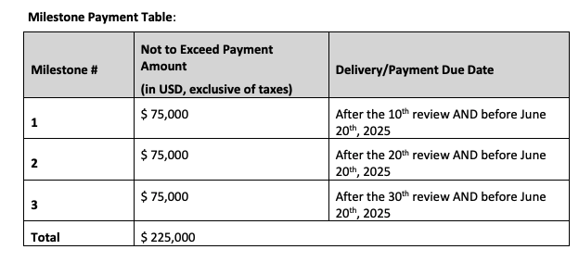

* 1. Estimated timelines for deliverables could also be embedded within the paragraphs describing the deliverable, and be identified as “**Approximately X weeks from SOW Effective Date**”. If this is seen, use this as the bill date for that deliverable. Example below:

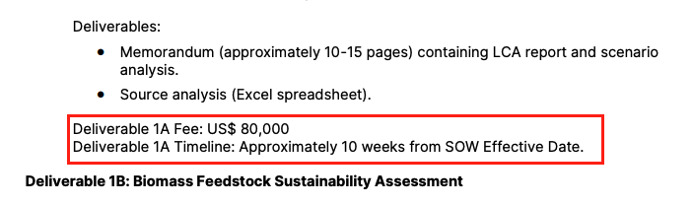

* 1. If there is a payment Due Date schedule, defer to that for milestone billing schedule:
     1. Use Payment Due Date as invoice date (as opposed to that being the actual due date of the invoice)

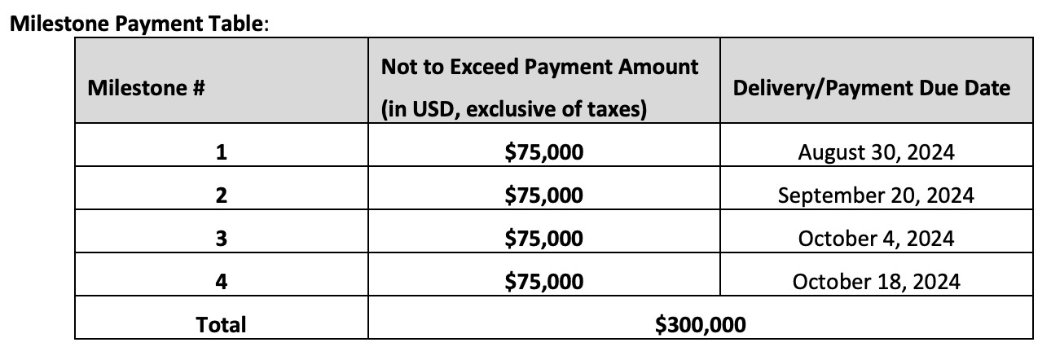

* 1. If there is a Project Title specified in a contract (many customer have multiple projects running at a time, each with their own contract):
     1. Use the project name in the title of the BT milestone
        1. Do not include the prefix “Energy_Carbon: Carbon Direct”
     2. Example: Microsoft projects
        1. BT Name: Rabobank Methodology Review: Milestone 1

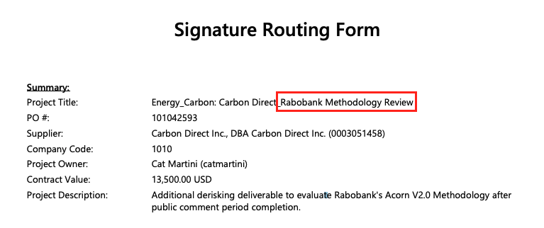

* 1. If there is a Retainer that is billed monthly, create 2 BTs:
     1. Retainer Fee (description: First month) that is billed on effective date as a one-off BT
     2. Retainer Fee that is recurring that starts the following full month on the first of the month
     3. Example of this: 9258eb4e-37fa-4e80-9f83-401c0ab74ceb
  2. They will also send through POs. For these, process as such:
     1. Customer: Name of Portfolio
     2. Date: Date of invoice, 1 occurrence, billing frequency = none
     3. Item title: Credits
     4. Quantity: Number of Credits
     5. Description: Price per credit
     6. Total: Total Purchase Price
     7. PLEASE ADD PO# TO INVOICE

Example below:

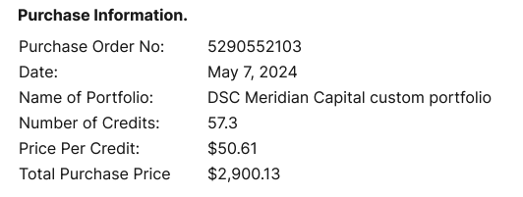

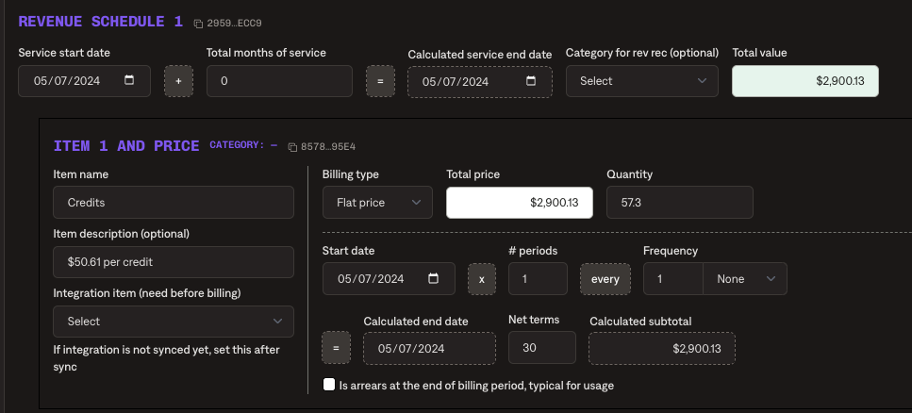

1. Anything to ignore in contracts?
2. Specifics processing things merchant has requested that may differ by contract (e.g. always back-date invoice date to final day of the month)
   1. If client name contains any version of "microsoft" associate the contract with QBO created customer "Microsoft (c)"
3. Default Service Term
   1. If None Listed, Ops Default is 1 Year
4. Default Net Payment Terms
   1. For microsoft contracts, please use 60 net terms as the default
   2. If None, Ops Default is 30
5. Default Billing Frequency
   1. If None Listed, Ops Default is Monthly
6. How do we handle taxes as a line item?
   1. If None Listed, Ops Default is every tax line item becomes a BT

### Events Processing (if necessary)

* Any important information on events billing

Integration Items Processing (if necessary)

* What are the instructions for assigning integration items?
  + When the contract is 50/50 up front and delivered
    - First 50% BT: **Services to be performed**
    - Second 50% BT - **Services already performed**
  + When billed upon delivery: **Advisory services**
  + Mesure analysis: **Platform services to be performed**
  + Advisory Services: **Advisory Services**
  + If the contracts invoices up front**: Services to be performed**
  + If there is milestone schedule with clear dates: **Advisory services**

**Project title in name of milestone**

Post Processing Communications (if necessary)

* Does Ops Team need to notify anyone on the team re: completion of processing batches in Implementation or Active phase?
* Who needs to be notified and when?
  + Example:
    - Who: Customer Success [Azmat Aziz] needs to be notified
    - Where: Messari internal merchant channel
    - When: contracts are processed [Merchant Phase: Active]

### Customer Information

* Any important information on specifics customers of this merchant
  + Special memo’s certain invoices require
  + Invoice changes due to merchant/customer relationship

### Feature Requests

* FR 1
  + What is it
  + Why it's important
  + Urgency

### Rewatch Calls

* Intro to Tabs call May 31 - <https://tabs.rewatch.com/video/jxkspzes8qbp50ma-intro-to-tabs-may-31-2024>
* Custom Demo on June 11 - <https://tabs.rewatch.com/video/q8y44y0dtm6ayk2q-tabs-carbon-direct-custom-demo-june-11-2024>
* Scoping Call on June 14 - <https://tabs.rewatch.com/video/ut5guypsvihghfpr-tabs-carbon-direct-june-14-2024>
* Partnerships discussion on June 17 - [https://tabs.rewatch.com/video/x1m 3uguepeob63qi-tabs-carbon-direct-partnerships-june-17-2024](https://tabs.rewatch.com/video/x1m3uguepeob63qi-tabs-carbon-direct-partnerships-june-17-2024)
* Final Partnerships discussion June 21 - <https://tabs.rewatch.com/video/h44dnyiw3at4ndob-hold-tabs-carbon-direct-june-21-2024>